## **1 Create and fill 3NF objects**

**Step 1: create tables and synonyms**

Example of code:

*DROP TABLE bl_3nf.ce_promotion_categories CASCADE CONSTRAINTS;*

*CREATE TABLE bl_3nf.ce_promotion_categories (*

*promotion_category_id NUMBER(38) NOT NULL,*

*promotion_category_srcid VARCHAR2(50 CHAR) NOT NULL,*

*promotion_category_source_system VARCHAR2(50 CHAR) NOT NULL,*

*promotion_category_source_entity VARCHAR2(50 CHAR) NOT NULL,*

*promotion_category VARCHAR2(50 CHAR) NOT NULL,*

*TA_UPDATE_DT DATE NOT NULL,*

*TA_INSERT_DT DATE NOT NULL*

*);*

*ALTER TABLE bl_3nf.ce_promotion_categories*

*ADD CONSTRAINT ce_promotion_category_pk*

*PRIMARY KEY (promotion_category_id );*

*CREATE PUBLIC SYNONYM ce_promotion_categories*

*FOR bl_3nf.ce_promotion_categories;*

*DROP TABLE bl_3nf.ce_promotions_scd CASCADE CONSTRAINTS;*

*CREATE TABLE bl_3nf.ce_promotions_scd (*

*promotion_id NUMBER(38) NOT NULL,*

*promotion_srcid VARCHAR2(50 CHAR) NOT NULL,*

*promotion_source_system VARCHAR2(50 CHAR) NOT NULL,*

*promotion_source_entity VARCHAR2(50 CHAR) NOT NULL,*

*promotion_name VARCHAR2(50 CHAR) NOT NULL,*

*promotion_category_id NUMBER(38) NOT NULL,*

*begin_sop_DT DATE NOT NULL,*

*end_eop_DT DATE NOT NULL,*

*is_active VARCHAR2(50 char) NOT NULL,*

*cost NUMBER(15,2) NOT NULL,*

*TA_UPDATE_DT DATE NOT NULL,*

*TA_INSERT_DT DATE NOT NULL*

*);*

*ALTER TABLE bl_3nf.ce_promotions_scd*

*ADD CONSTRAINT ce_promotions_scd_pk*

*PRIMARY KEY ( promotion_id, begin_sop_dt );*

*ALTER TABLE bl_3nf.ce_promotions_scd*

*ADD CONSTRAINT ce_promotions_scd_ce_promotion_class_fk*

*FOREIGN KEY ( promotion_category_id )*

*REFERENCES bl_3nf.ce_promotion_categories ( promotion_category_id );*

Code for the rest tables in folder scripts

**Step 2: Fill tables**

I have used Merge function. I loaded data from 2 sources for *ce_channels* and *ce_customers* tables. For the rest tables I have choose dominant source - personnel_sales and loaded data only from this source.

Example of code:

*MERGE INTO ce_channel_classes ch*

*USING (SELECT DISTINCT*

*channel_class_id AS channel_class_srcid,*

*'personnel_sales' AS channel_class_source_system,*

*'src_channels' AS channel_class_source_entity,*

*COALESCE(channel_class,'N/A')AS channel_class*

*FROM SA_SOURCE_SYSTEM_1.src_channels*

*) t*

*ON (ch.channel_class_srcid = t.channel_class_srcid*

*AND ch.channel_class_source_system = t.channel_class_source_system*

*AND ch.channel_class_source_entity = t.channel_class_source_entity)*

*WHEN NOT MATCHED THEN*

*INSERT( channel_class_id,channel_class_srcid, channel_class_source_system, channel_class_source_entity, channel_class, ta_update_dt, ta_insert_dt)*

*VALUES(seq_ce_channel_class_id.NEXTVAL,t.channel_class_srcid, t.channel_class_source_system, t.channel_class_source_entity, t.channel_class, SYSDATE,SYSDATE);*

*MERGE INTO ce_channel_classes ch*

*USING (SELECT DISTINCT*

*-1 AS channel_class_id,*

*-1 AS channel_class_srcid,*

*'personnel_sales' AS channel_class_source_system,*

*'src_channels' AS channel_class_source_entity,*

*'N/A' AS channel_class*

*FROM DUAL*

*) t*

*ON (ch.channel_class_srcid = t.channel_class_srcid*

*AND ch.channel_class_source_system = t.channel_class_source_system*

*AND ch.channel_class_source_entity = t.channel_class_source_entity)*

*WHEN NOT MATCHED THEN*

*INSERT( channel_class_id,channel_class_srcid, channel_class_source_system, channel_class_source_entity, channel_class, ta_update_dt, ta_insert_dt)*

*VALUES(t.channel_class_id,t.channel_class_srcid, t.channel_class_source_system, t.channel_class_source_entity, t.channel_class, SYSDATE,SYSDATE);*

*SELECT * FROM ce_channel_classes;*

*commit;*

Code for the rest tables in folder scripts

**Step3: results**

SELECT * FROM ce_channel_classes;

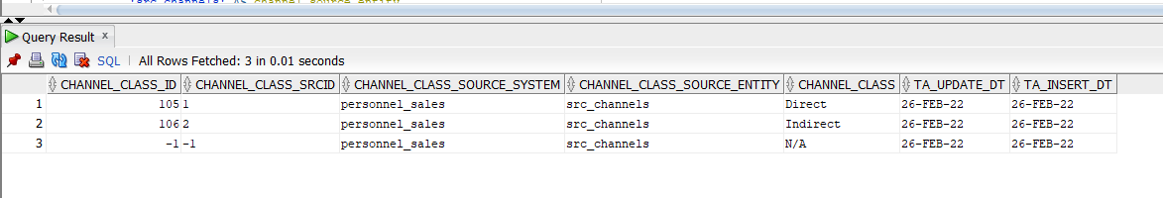

SELECT * FROM ce_channels;

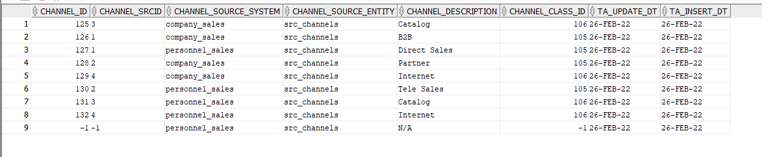

SELECT * FROM ce_promotion_categories;

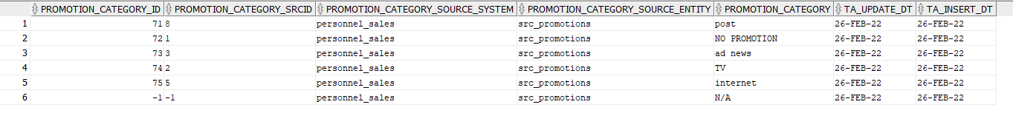

SELECT * FROM ce_promotions_scd;

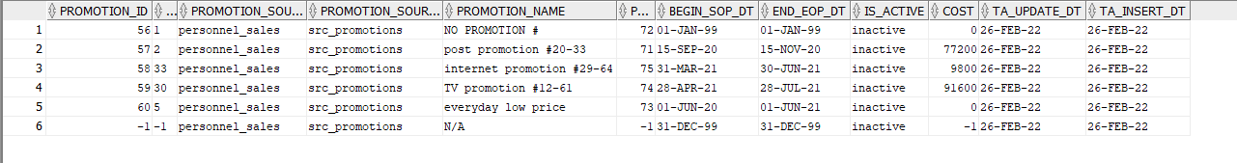

SELECT * FROM ce_brands;

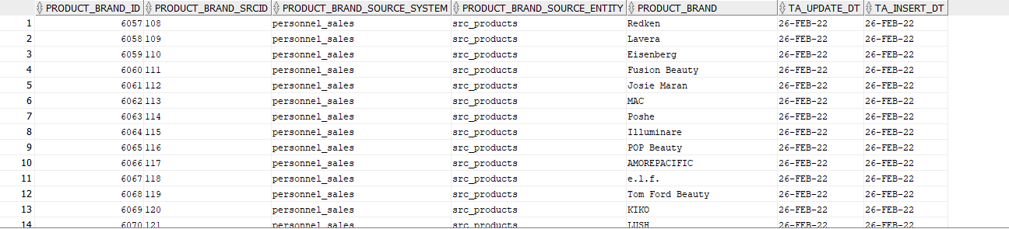

SELECT * FROM ce_product_types;

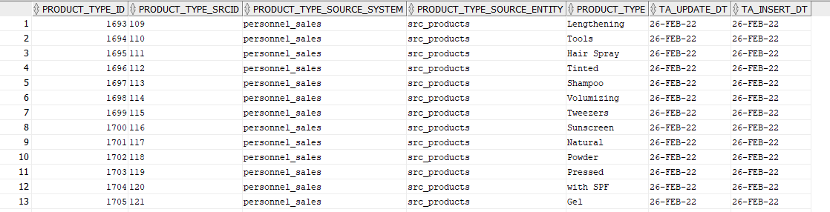

SELECT * FROM ce_products;

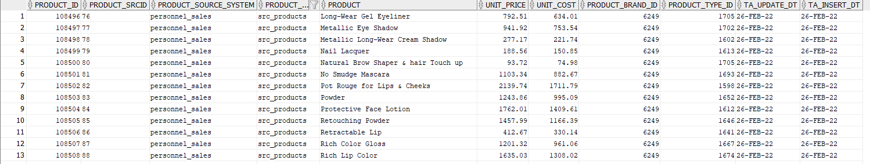

SELECT * FROM ce_countries;

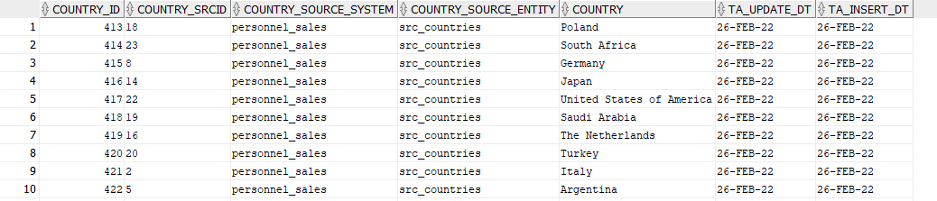

SELECT * FROM ce_states;

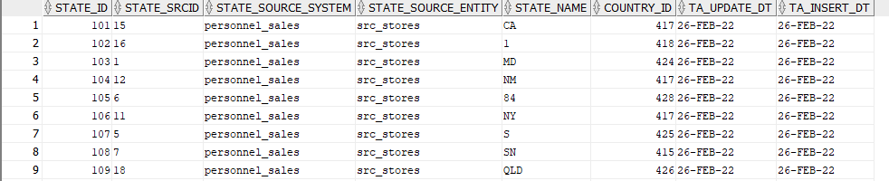

SELECT * FROM ce_cities;

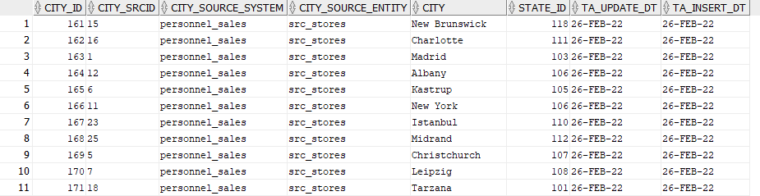

SELECT * FROM ce_addresses;

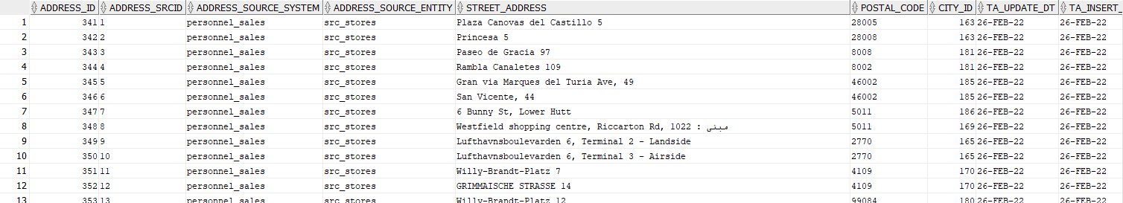

SELECT * FROM ce_stores;

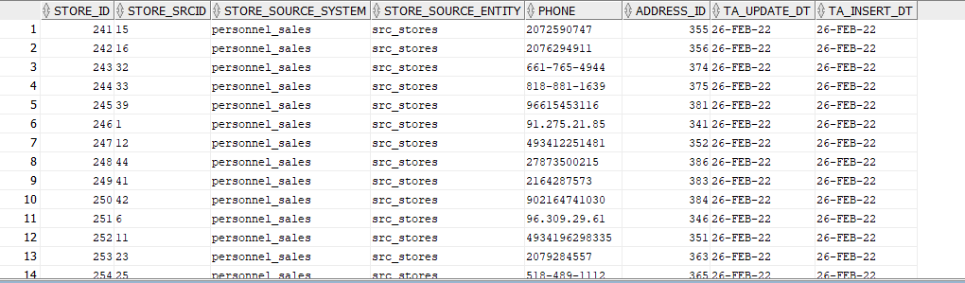

SELECT * FROM ce_customers;

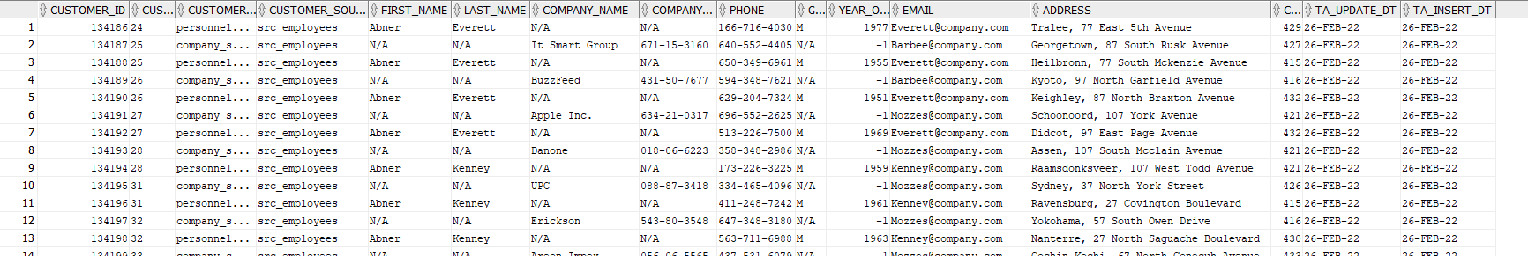

SELECT * FROM ce_positions;

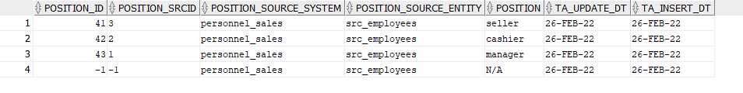

SELECT * FROM ce_employees;

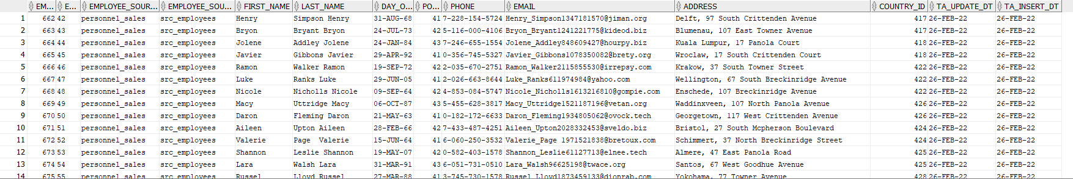

SELECT * FROM ce_sales;

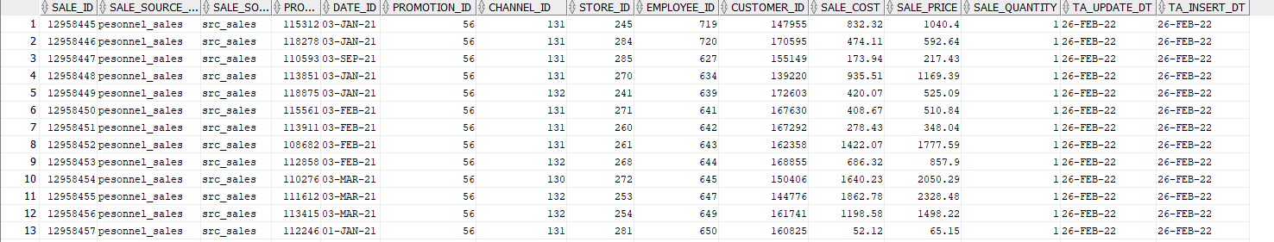

## **1 Create objects for star schema**

**Step 1: create objects**

*drop table dim_channels CASCADE CONSTRAINTS;*

*CREATE TABLE dim_channels (*

*channel_surr_id NUMBER(38) NOT NULL,*

*channel_id VARCHAR2(50) NOT NULL,*

*source_system VARCHAR2(50) NOT NULL,*

*source_entity VARCHAR2(50) NOT NULL,*

*channel_description VARCHAR2(50) NOT NULL,*

*channel_class_id NUMBER(38) NOT NULL,*

*channel_class VARCHAR2(50) NOT NULL,*

*ta_update_dt DATE NOT NULL,*

*ta_insert_dt DATE NOT NULL*

*);*

*ALTER TABLE dim_channels ADD CONSTRAINT dim_channels_pk PRIMARY KEY ( channel_surr_id );*

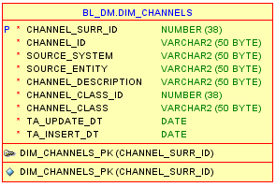

*drop table dim_customers CASCADE CONSTRAINTS;*

*CREATE TABLE dim_customers (*

*customer_surr_id NUMBER(38) NOT NULL,*

*customer_id VARCHAR2(50) NOT NULL,*

*source_system VARCHAR2(50) NOT NULL,*

*source_entity VARCHAR2(50) NOT NULL,*

*first_name VARCHAR2(50) NOT NULL,*

*last_name VARCHAR2(50) NOT NULL,*

*company_name VARCHAR2(50) NOT NULL,*

*phone VARCHAR2(50) NOT NULL,*

*company_number VARCHAR2(50) NOT NULL,*

*gender VARCHAR2(50) NOT NULL,*

*yeart_of_birth NUMBER(38) NOT NULL,*

*email VARCHAR2(50) NOT NULL,*

*country VARCHAR2(50) NOT NULL,*

*country_id NUMBER(38) NOT NULL,*

*address VARCHAR2(50) NOT NULL,*

*ta_update_dt DATE NOT NULL,*

*ta_insert_dt DATE NOT NULL*

*);*

*ALTER TABLE dim_customers ADD CONSTRAINT dim_customers_pk PRIMARY KEY ( customer_surr_id );*

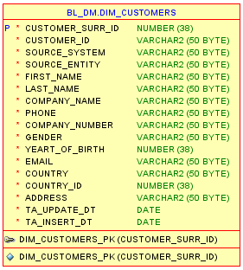

*drop table dim_employees CASCADE CONSTRAINTS;*

*CREATE TABLE dim_employees (*

*employee_surr_id NUMBER(38) NOT NULL,*

*employee_id VARCHAR2(50) NOT NULL,*

*source_system VARCHAR2(50) NOT NULL,*

*source_entity VARCHAR2(50) NOT NULL,*

*first_name VARCHAR2(50) NOT NULL,*

*last_name VARCHAR2(50) NOT NULL,*

*day_of_birthday_dt DATE NOT NULL,*

*position_id NUMBER(38) NOT NULL,*

*position VARCHAR2(50) NOT NULL,*

*phone VARCHAR2(50) NOT NULL,*

*email VARCHAR2(50) NOT NULL,*

*address VARCHAR2(50) NOT NULL,*

*country_id NUMBER(38) NOT NULL,*

*country VARCHAR2(50) NOT NULL,*

*ta_update_dt DATE NOT NULL,*

*ta_insert_dt DATE NOT NULL*

*);*

*ALTER TABLE dim_employees ADD CONSTRAINT dim_employees_scd_pk PRIMARY KEY ( employee_surr_id );*

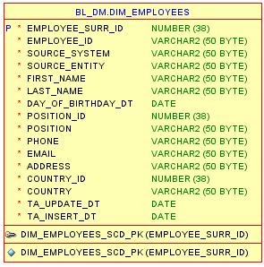

*drop table dim_products CASCADE CONSTRAINTS;*

*CREATE TABLE dim_products (*

*product_surr_id NUMBER(38) NOT NULL,*

*product_id VARCHAR2(50) NOT NULL,*

*source_system VARCHAR2(50) NOT NULL,*

*source_entity VARCHAR2(50) NOT NULL,*

*product_name VARCHAR2(50) NOT NULL,*

*product_brand_id NUMBER(38) NOT NULL,*

*product_brand VARCHAR2(50) NOT NULL,*

*product_type_id NUMBER(38) NOT NULL,*

*product_type VARCHAR2(50) NOT NULL,*

*ta_update_dt DATE NOT NULL,*

*ta_insert_dt DATE NOT NULL*

*);*

*ALTER TABLE dim_products ADD CONSTRAINT dim_products_pk PRIMARY KEY ( product_surr_id );*

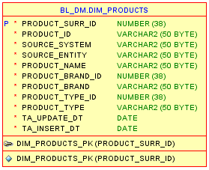

*drop table dim_promotions_scd CASCADE CONSTRAINTS;*

*CREATE TABLE dim_promotions_scd (*

*promotion_surr_id NUMBER(38) NOT NULL,*

*promotion_id VARCHAR2(50) NOT NULL,*

*source_system VARCHAR2(50) NOT NULL,*

*source_entity VARCHAR2(50) NOT NULL,*

*promotion_name VARCHAR2(50) NOT NULL,*

*promotion_category_id NUMBER(38) NOT NULL,*

*promotion_categoty VARCHAR2(50) NOT NULL,*

*begin_sop_dt DATE NOT NULL,*

*end_eop_dt DATE NOT NULL,*

*is_active VARCHAR2(50) NOT NULL,*

*cost NUMBER(15, 2) NOT NULL,*

*ta_update_dt DATE NOT NULL,*

*ta_insert_dt DATE NOT NULL*

*);*

*ALTER TABLE dim_promotions_scd ADD CONSTRAINT dim_promotions_scd_pk PRIMARY KEY ( promotion_surr_id );*

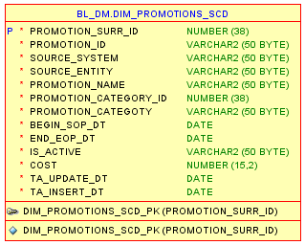

*drop table dim_stores CASCADE CONSTRAINTS;*

*CREATE TABLE dim_stores (*

*store_surr NUMBER(38) NOT NULL,*

*store_id VARCHAR2(50) NOT NULL,*

*source_system VARCHAR2(50) NOT NULL,*

*source_entity VARCHAR2(50) NOT NULL,*

*phone VARCHAR2(50) NOT NULL,*

*street_address VARCHAR2(50) NOT NULL,*

*postal_code VARCHAR2(50) NOT NULL,*

*city_id NUMBER(38) NOT NULL,*

*city VARCHAR2(50) NOT NULL,*

*state_id NUMBER(38) NOT NULL,*

*state VARCHAR2(50) NOT NULL,*

*country_id NUMBER(38) NOT NULL,*

*country VARCHAR2(50) NOT NULL,*

*ta_update_dt DATE NOT NULL,*

*ta_insert_dt DATE NOT NULL*

*);*

*ALTER TABLE dim_stores ADD CONSTRAINT dim_stores_pk PRIMARY KEY ( store_surr );*

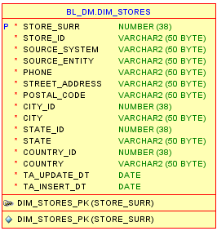

*drop table fct_sales CASCADE CONSTRAINTS;*

*CREATE TABLE fct_sales (*

*source_system VARCHAR2(50) NOT NULL,*

*soutce_entity VARCHAR2(50) NOT NULL,*

*product_surr_id NUMBER(38) NOT NULL,*

*promotion_surr_id NUMBER(38) NOT NULL,*

*channel_surr_id NUMBER(38) NOT NULL,*

*store_surr_id NUMBER(38) NOT NULL,*

*employee_surr_id NUMBER(38) NOT NULL,*

*customer_surr_id NUMBER(38) NOT NULL,*

*date_id DATE NOT NULL,*

*unit_cost NUMBER(15, 2),*

*unit_price NUMBER(15, 2),*

*sales_quantity NUMBER(38),*

*ta_update_dt DATE NOT NULL,*

*ta_insert_dt DATE NOT NULL*

*);*

